LESSON 6.

Classification, morphology and ultrastructure of fungi

LESSON PLAN:
- Structural features of eukaryotic cells.
- Classification of fungi
- Primitive and higher fungi
- Perfect and imperfect fungi
- Morphology, ultrastructure of fungi.
- Mycelial, yeast, yeast-like, dimorphic fungi.
- Reproductive characteristics of fungi: sexual and asexual reproduction.
- Pathogenic fungi of the types Zygomycota, Ascomycota, Basidiomycota and Deuteromycota.
- The examination methods of fungi morphology.

Fungi (Fungi, Mycetes, Mycota) are plant-based, chlorophyll-free, single- or multi-celled eukaryotic organisms
The branch of microbiology that studies fungi is called mycology
There are pathogenic and non-pathogenic types of fungi
Morphology of fungi
- Mycelial or filamentous fungi
- Yeasts and yeast-like fungi
- Mycelial or filamentous fungi
- They are composed from long filamentous cells of hyphae.
- Hyphae branch out to form mycelium.
- Mycelium may be septate or aseptate.
- In primitive fungi, mycelium is aseptate.
- In most fungi, hyphae are divided into cells by internal cross-walls called "septa“
- Substrate or vegetative mycelium that grows on and into the culture medium and, as the colony matures
- The portion of mycelium that grows upward or outward from the surface of the substrate is called the aerial mycelium or the reproductive mycelium
Yeasts fungi (Saccharomycetes)
- True yeasts are round, oval or rod-shaped single-celled fungi. Fungi reproduce both sexually and asexually
- Asexual reproduction occurs through budding.
- Yeast fungi also reproduce by forming ascospores. At this time, 2,4,8 ascospores, etc. are formed inside the sac that called the ascus
- An ascospore is a spore contained in an ascus or that was produced inside an ascus
- Yeast fungi are widely used in baking, dairy production, etc.
Yeast-like fungi
- They are morphologically similar to real yeasts.
- They are single-celled, round or oval-shaped fungi reproduce through budding
- Sometimes the buds grow longitudinally without leaving the mother cell and form derivatives called pseudomycelium. For example, Candida fungi.
Dimorphism of fungi
- Dimorphic fungi are fungi that have a yeast (or yeast-like) phase and a mold (filamentous) phase
- Mold form typically exist in the environment and nutrient media and yeast-like form in the human body
- Most causative agents of subcutaneous and systemic mycoses have dimorphism
Reproduction of fungi
- Sexual reproduction - the formation of sexual gametes, the formation of sexual spores (zygospores, ascospores, basidospores)
- Asexual reproduction-budding, fragmentation of hyphae, formation of asexual spores (arthroconidia, blastoconidia, chlamydoconidia)
- It is divided into 2 parts depending on whether the fungus has sexual reproduction or not
- Perfect (Reproduced both asexually and sexually)
- Imperfect (Reproduced asexually)
The main reproductive organ of fungi is spores
- If the spore is located inside the mycelium, it is called an endospore
- Endospores are formed within special structures - sporangia. This type of spore formation is characteristic of fungi of the genus Mucor
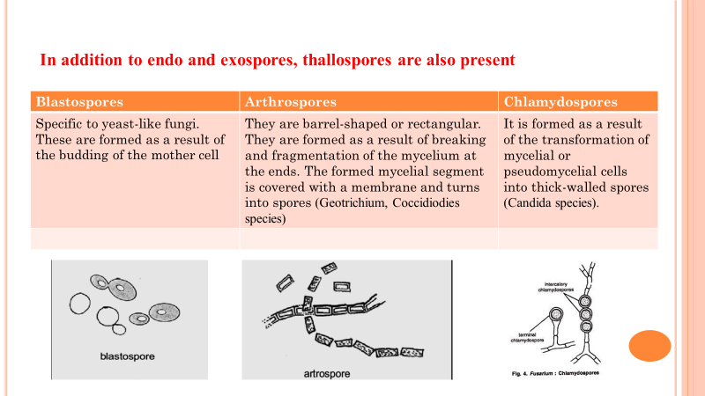
- Spores that form outside the mycelium are called exospores or conidia
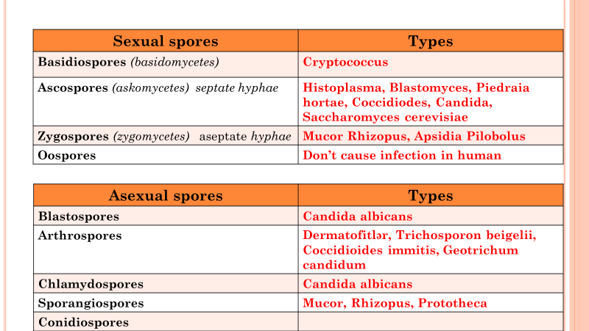

- In the fungi Penicillium and Aspergillus, elongated cells-sterigums are formed at the ends of the reproductive mycelium-conidia. Conidia are arranged in a chain on them.
Conidia may be unicellular (microconidia) and multicellular (macroconidia).

- In the modern classification, fungi are divided into types.
- Depending on whether there is sexual reproduction, all fungi are divided into advanced and immature fungi.
- Advanced fungi reproduce not only asexually but also sexually.
- In immature fungi, no sexual reproduction has been detected, but this is a condition, as they are referred to the appropriate types as soon as sexual reproduction is detected in these fungi.

Classification of fungi
Zygomycotes (Zyqomycota) - Reproduced sexually and asexually. Sexual reproduction is through zygospores (zygos-mergers), and asexual reproduction is through sporangiospores. Vegetative forms are aseptate. Pathogenic types to humans are Rhizopus, Absidia, Mucor, etc.
Ascomycota - The largest type of fungus. Sexual reproduction is through ascospores (asc-sac), asexual reproduction is through conidia. Vegetative mycelium is septate. It contains about 85% of fungi that are pathogenic to humans.
Blastomyces, Histoplasma, Candida, Trichophyton, Coccidoides, Arthrodernma, Saccharomyces, etc
    - Basidiomycotes - sexual reproduction occurs through basidiospores (basidiomycetes). The mycelium is septate.
    - Pathogen types for humans - Filobasidiella neoformans, Cryptococcus neoformans, etc.
- Deuteromycetes (immature fungi - Deiteromtcota, Fungi imperfecti) - this is a conventional type.
- Pathogen types for humans- Coccidioides immitis, coccidioides posadasii, Sporothrix, Aspergillus, Epidermophyton, Paracoccidioides, Phialophora, etc.
METHODS OF STUDYING MORPHOLOGY OF FUNGI
- Simple staining, Gram staining, lactophenol staining, etc.
The crushed drop method
skin scales, hairs, nails, etc. preparations for the detection of fungal elements are performed with an alkaline solution (15-20% KOH)

